PT5300 and PT5211 – Ground connection mounting instruction
Modification introduced 2013-05-21
Thomas Holm Hansen

The internal ground connection in the PT5300 and PT5211 instruments, must be done according to the following description to ensure compliance to the required safety regulations.

The crimp screw connector termination on the ground wires from the power supply and the IEC mains connector, must be connected to the chassis in a way in which it is not possible to remove the connection from outside the instrument. Furthermore an internal marking of the protective earth (ground) must be made. This is done by using the following parts:

- Label with the “Protective earth (ground)” symbol (IEC 60417-5019)
- M4 A2 Nut
- M4 A2 Locking washer
- M4 A2 Grounding washer
- M4 A2 Washer
- M4 x 12 A2 Safety screw with one-way drive

The parts are shown in Illustration 1.

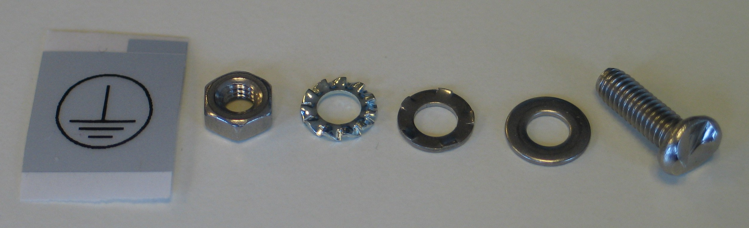Illustration 1: Parts used for the grounding connection to chassis, from left: Protective earth (ground) label, M4 A2 Nut, M4 A2 Locking Washer, M4 A2 Grounding Washer, M4 A2 Washer, M4 x 12 A2 Safety screw with one-way drive.
The crimp screw connector termination on the ground wires (green-yellow) from the IEC mains connector and the power supply is mounted to the chassis as shown on Illustration 2 and Illustration 3.

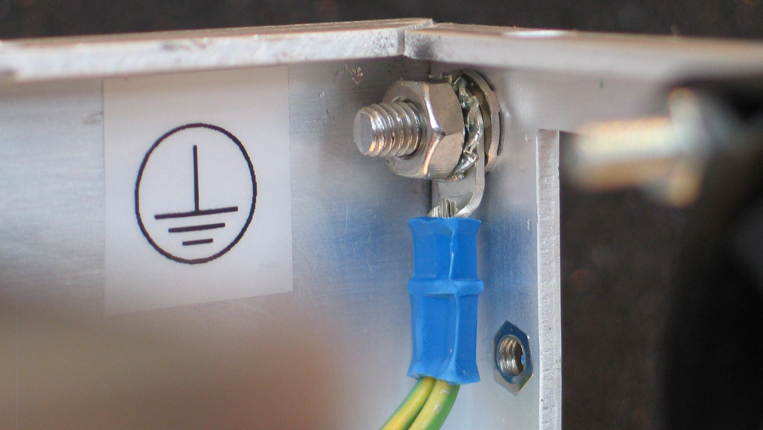Illustration 2: Label with the protective earth (ground) is placed next to the ground connection to chassis. The crimp screw connector must be crimped on the ground wires (soldering is not allowed). On the grounding screw next to the chassis is the grounding washer, then the crimp screw connector terminal, then the locking washer, and finally the nut. Note that the sharp side of the grounding washer must be facing towards the cabinet.

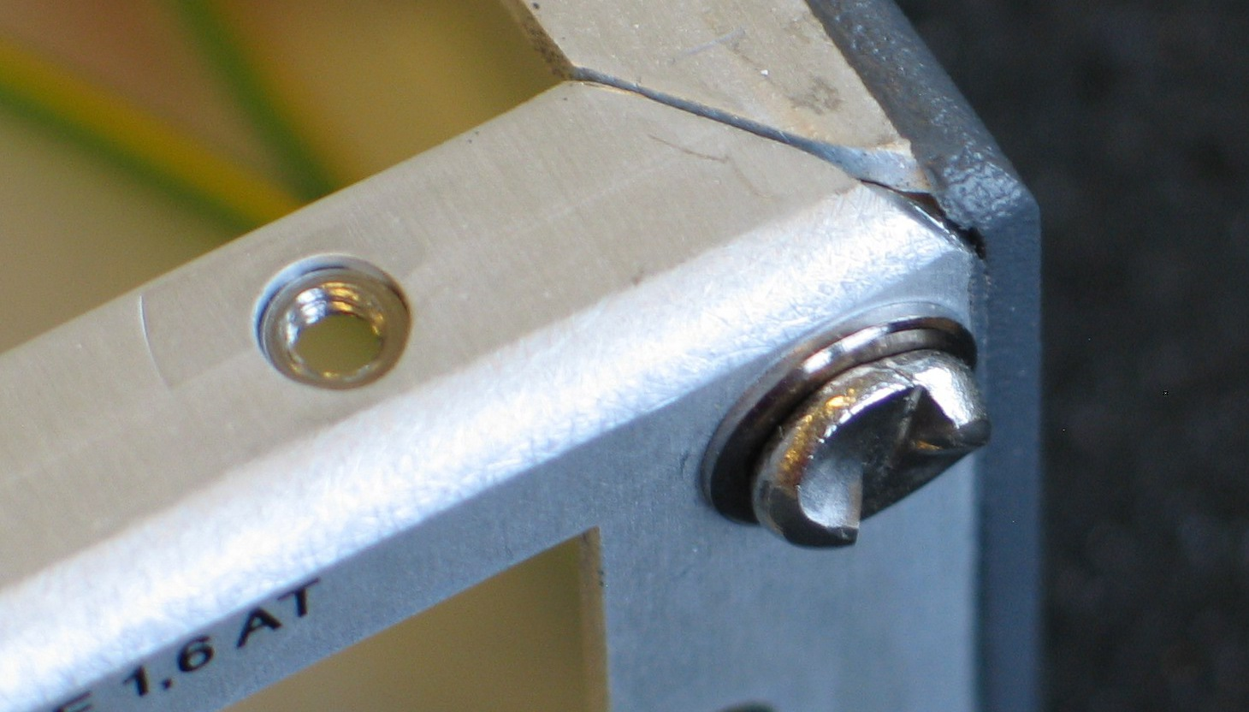Illustration 3:From outside the cabinet is shown the head of the safety screw and the washer.

